**Find the Most Influential Node in the**

**Graph using Brande’s Algorithm**

1. **Progress**

I understood Brande’s Algorithm and tried to implement the algorithm given on the below link:

<http://algo.uni-konstanz.de/publications/b-fabc-01.pdf>

The code can be found on the GitHub link:

<https://github.com/ssgandham/Advanced-Data-Engineering-Term-Project>

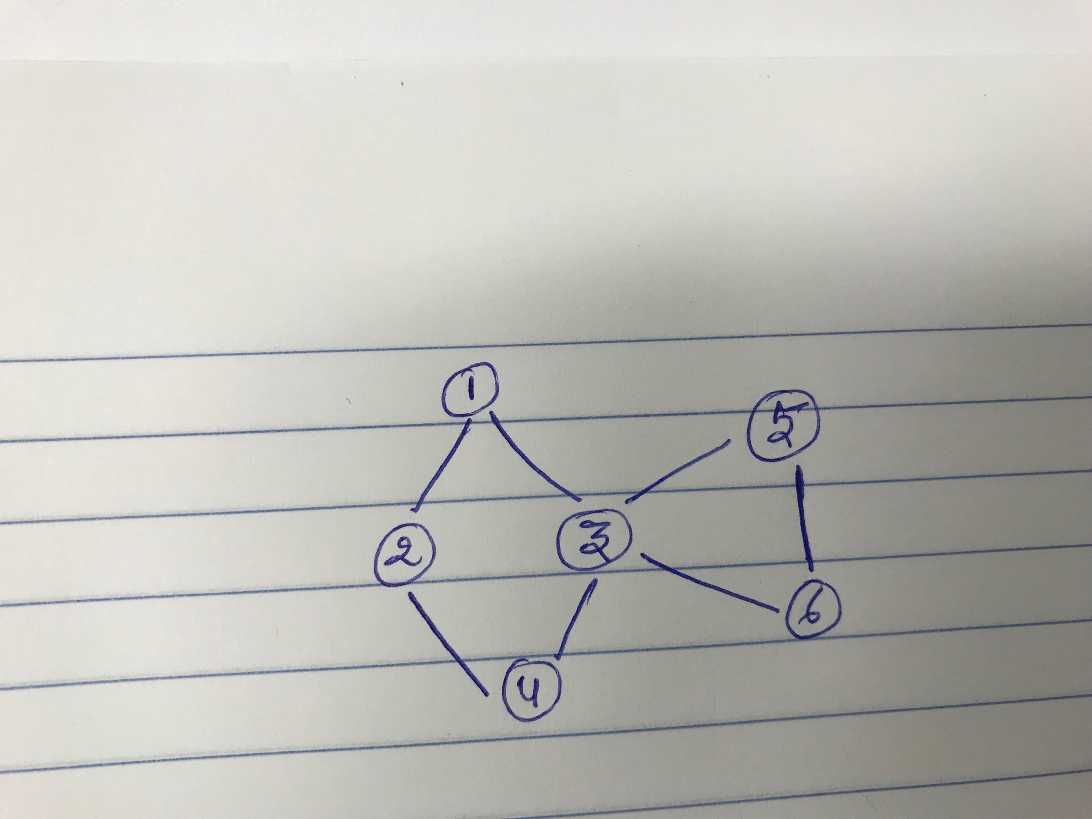

I’m getting the following Betweeness centrality Values for the above graph:

0 0 0 2 0 0 0

**To do:**

I’ve to figure out why I’m getting zero for rest of the vertices.

I still have to consider the weights of edges as well as see if other centralities such as Closeness, Graph or Stress can be computed.

